LAB 03 DATE: 15 JAN 2024
BOOTSTRAP

220905524, Pranay Goel, B 2

Q1. Design the student bio-data form using button, label, textbox, radio button, table and checkbox.
CODE:
<!DOCTYPE html>
<html lang="en">
<head>
<meta charset="UTF-8">
<meta name="viewport" content="width=device-width, initial-scale=1.0">
<title>Student Bio-Data Form</title>
<!-- Bootstrap CSS -->
<link href="https://cdn.jsdelivr.net/npm/bootstrap@5.3.0/dist/css/bootstrap.min.css" rel="stylesheet">
</head>
<body>
<div class="container my-5">
<h2 class="text-center mb-4">Student Bio-Data Form</h2>
<form>
<!-- Personal Information -->
<div class="mb-3">
<label for="name" class="form-label">Full Name</label>
<input type="text" class="form-control" id="name" placeholder="Enter your full name">
</div>
<div class="mb-3">
<label for="email" class="form-label">Email</label>
<input type="email" class="form-control" id="email" placeholder="Enter your email">
</div>
<div class="mb-3">
<label for="phone" class="form-label">Phone Number</label>
<input type="tel" class="form-control" id="phone" placeholder="Enter your phone number">
</div>

<!-- Gender Selection -->
<div class="mb-3">
<label class="form-label">Gender</label><br>
<div class="form-check form-check-inline">
<input class="form-check-input" type="radio" name="gender" id="male" value="male">
<label class="form-check-label" for="male">Male</label>
</div>
<div class="form-check form-check-inline">
<input class="form-check-input" type="radio" name="gender" id="female" value="female">
<label class="form-check-label" for="female">Female</label>
</div>
<div class="form-check form-check-inline">
<input class="form-check-input" type="radio" name="gender" id="other" value="other">
<label class="form-check-label" for="other">Other</label>
</div>
</div>

<!-- Address -->
<div class="mb-3">
<label for="address" class="form-label">Address</label>
<textarea class="form-control" id="address" rows="3" placeholder="Enter your address"></textarea>
</div>

<!-- Hobbies -->
<div class="mb-3">
<label class="form-label">Hobbies</label><br>
<div class="form-check">
<input class="form-check-input" type="checkbox" value="reading" id="reading">
<label class="form-check-label" for="reading">Reading</label>
</div>
<div class="form-check">
<input class="form-check-input" type="checkbox" value="sports" id="sports">
<label class="form-check-label" for="sports">Sports</label>
</div>
<div class="form-check">
<input class="form-check-input" type="checkbox" value="music" id="music">
<label class="form-check-label" for="music">Music</label>
</div>
</div>

<!-- Academic Information -->
<label class="form-label">Academic Records</label>
<table class="table table-bordered">
<thead class="table-dark">
<tr>
<th>Degree</th>
<th>Year of Completion</th>
<th>Percentage/CGPA</th>
</tr>
</thead>
<tbody>
<tr>
<td><input type="text" class="form-control" placeholder="Enter degree"></td>
<td><input type="text" class="form-control" placeholder="Enter year"></td>
<td><input type="text" class="form-control" placeholder="Enter percentage/CGPA"></td>
</tr>
</tbody>
</table>

<!-- Submit Button -->
<div class="text-center">
<button type="submit" class="btn btn-primary">Submit</button>
<button type="reset" class="btn btn-secondary">Reset</button>
</div>
</form>
</div>

<!-- Bootstrap JS -->
<script src="https://cdn.jsdelivr.net/npm/bootstrap@5.3.0/dist/js/bootstrap.bundle.min.js"></script>
</body>
</html>

OUTPUT:
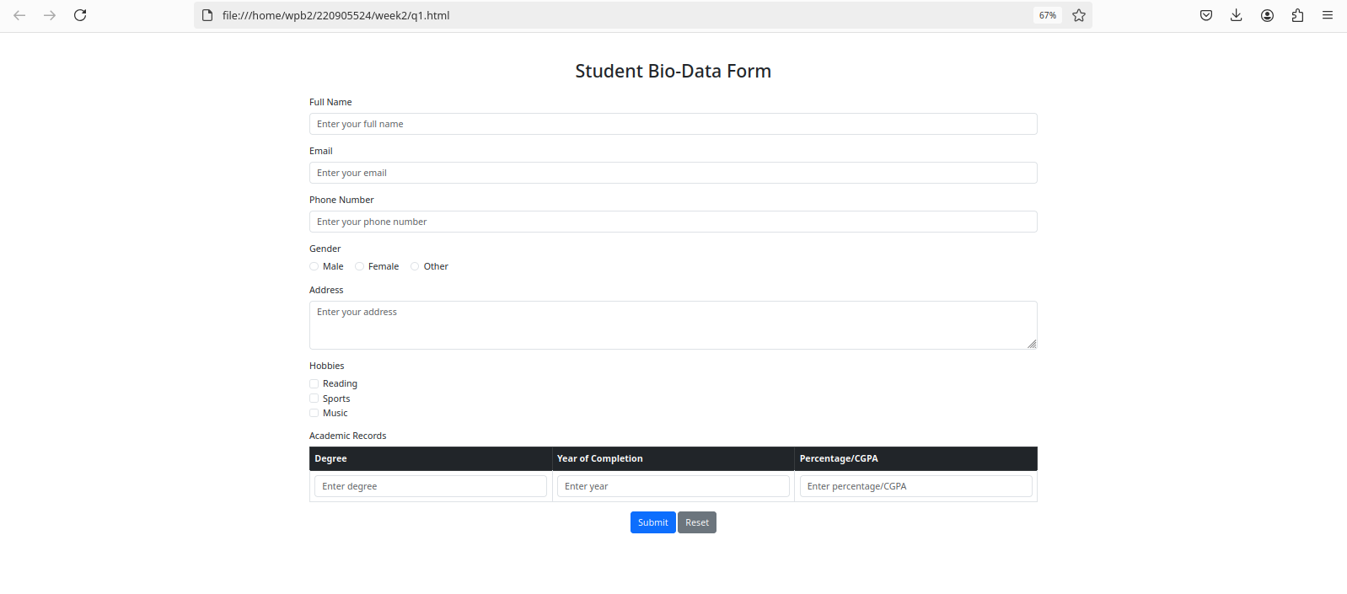

Q2. Design a web page which shows the database oriented CRUD operation. Consider Employee data.

CODE:

<!DOCTYPE html>
<html lang="en">
<head>
<meta charset="UTF-8">
<meta name="viewport" content="width=device-width, initial-scale=1.0">
<title>Employee Data CRUD</title>
<style>
body {
font-family: Arial, sans-serif;
margin: 0;
padding: 20px;
background-color: #f4f4f4;
}

h1 {
text-align: center;
}

.container {
width: 70%;
margin: auto;
padding: 20px;
background-color: white;
box-shadow: 0 0 10px rgba(0, 0, 0, 0.1);
}

.form-container {
margin-bottom: 20px;
}

.form-container input[type="text"],
.form-container input[type="email"],
.form-container input[type="number"],
.form-container button {
width: 100%;
padding: 10px;
margin-bottom: 10px;
border: 1px solid #ddd;
border-radius: 4px;
}

button {
background-color: #4CAF50;
color: white;
cursor: pointer;
}

button:hover {
background-color: #45a049;
}

table {
width: 100%;
border-collapse: collapse;
margin-top: 20px;
}

table, th, td {
border: 1px solid #ddd;
}

th, td {
padding: 10px;
text-align: left;
}

th {
background-color: #f2f2f2;
}

.actions button {
padding: 5px 10px;
margin-right: 5px;
border: none;
color: white;
cursor: pointer;
}

.edit-btn {
background-color: #ff9800;
}

.delete-btn {
background-color: #f44336;
}
</style>
</head>
<body>

<div class="container">
<h1>Employee Data CRUD</h1>

<!-- Form for adding/updating employee -->
<div class="form-container">
<h2>Employee Form</h2>
<form id="employeeForm">
<input type="hidden" id="employeeId"> <!-- Hidden input for employee ID during edit -->

<label for="empName">Employee Name:</label>
<input type="text" id="empName" placeholder="Enter employee name" required>

<label for="empEmail">Email:</label>
<input type="email" id="empEmail" placeholder="Enter employee email" required>

<label for="empPosition">Position:</label>
<input type="text" id="empPosition" placeholder="Enter employee position" required>

<label for="empSalary">Salary:</label>
<input type="number" id="empSalary" placeholder="Enter employee salary" required>

<button type="submit">Submit</button>
</form>
</div>

<!-- Table to display employee data -->
<div class="table-container">
<h2>Employee Records</h2>
<table id="employeeTable">
<thead>
<tr>
<th>Name</th>
<th>Email</th>
<th>Position</th>
<th>Salary</th>
<th>Actions</th>
</tr>
</thead>
<tbody>
<!-- Employee records will be displayed here -->
</tbody>
</table>
</div>
</div>

<script>
let employees = [
{ id: 1, name: 'John Doe', email: 'john@example.com', position: 'Developer', salary: 50000 },
{ id: 2, name: 'Jane Smith', email: 'jane@example.com', position: 'Manager', salary: 60000 }
];

function displayEmployeeData() {
const tableBody = document.querySelector('#employeeTable tbody');
tableBody.innerHTML = '';
employees.forEach(emp => {
const row = tableBody.insertRow();
row.innerHTML = `
<td>${emp.name}</td>
<td>${emp.email}</td>
<td>${emp.position}</td>
<td>${emp.salary}</td>
<td class="actions">
<button class="edit-btn" onclick="editEmployee(${emp.id})">Edit</button>
<button class="delete-btn" onclick="deleteEmployee(${emp.id})">Delete</button>
</td>
`;
});
}

document.getElementById('employeeForm').addEventListener('submit', function(event) {
event.preventDefault();

const employeeId = document.getElementById('employeeId').value;
const name = document.getElementById('empName').value;
const email = document.getElementById('empEmail').value;
const position = document.getElementById('empPosition').value;
const salary = document.getElementById('empSalary').value;

if (employeeId) {
const employeeIndex = employees.findIndex(emp => emp.id == employeeId);
if (employeeIndex !== -1) {
employees[employeeIndex] = { id: employeeId, name, email, position, salary };
}
} else {
const newEmployee = {
id: employees.length + 1,
name,
email,
position,
salary
};
employees.push(newEmployee);
}

document.getElementById('employeeForm').reset();
document.getElementById('employeeId').value = '';
displayEmployeeData();
});

function editEmployee(id) {
const employee = employees.find(emp => emp.id === id);
if (employee) {
document.getElementById('empName').value = employee.name;
document.getElementById('empEmail').value = employee.email;
document.getElementById('empPosition').value = employee.position;
document.getElementById('empSalary').value = employee.salary;
document.getElementById('employeeId').value = employee.id;
}
}

function deleteEmployee(id) {
employees = employees.filter(emp => emp.id !== id);
displayEmployeeData();
}

displayEmployeeData();
</script>
</body>
</html>

PTO
OUTPUT:
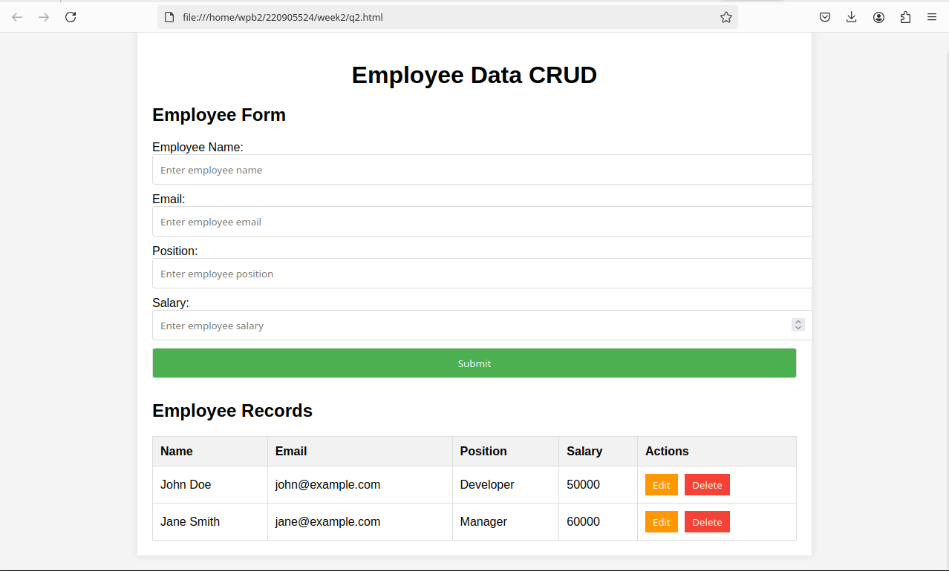

Q3. Create a web page using bootstrap as mentioned. Divide the page in to 2 parts top and bottom, then divide the bottom into 3 parts and design each top and bottom part using different input groups, input, badges, buttons and button groups. Make the design more attractive.

CODE:

<!DOCTYPE html>
<html lang="en">
<head>
<meta charset="UTF-8">
<meta name="viewport" content="width=device-width, initial-scale=1.0">
<title>Bootstrap Page</title>
<!-- Bootstrap CSS -->
<link href="https://cdn.jsdelivr.net/npm/bootstrap@5.3.0-alpha1/dist/css/bootstrap.min.css" rel="stylesheet">
<style>
body {
background-color: #f8f9fa;
}
.container {
margin-top: 30px;
}
.top-section {
background-color: #e9ecef;
padding: 20px;
border-radius: 8px;
}
.bottom-section {
margin-top: 20px;
}
.bottom-part {
background-color: #fff;
padding: 15px;
border-radius: 8px;
box-shadow: 0 4px 6px rgba(0, 0, 0, 0.1);
}
.btn-custom {
margin-top: 10px;
}
</style>
</head>
<body>

<div class="container">
<!-- Top Section -->
<div class="top-section">
<h4>Top Section</h4>
<div class="input-group mb-3">
<span class="input-group-text" id="basic-addon1">@</span>
<input type="text" class="form-control" placeholder="Username" aria-label="Username" aria-describedby="basic-addon1">
<button class="btn btn-primary">Submit</button>
<span class="badge bg-success ms-2">Active</span>
</div>
</div>

<!-- Bottom Section -->
<div class="row bottom-section">
<!-- Bottom Part 1 -->
<div class="col-md-4 bottom-part">
<h5>Part 1: Input and Buttons (LEFT)</h5>
<div class="input-group mb-3">
<input type="text" class="form-control" placeholder="Enter your name">
<button class="btn btn-outline-primary">Search</button>
</div>
</div>

<!-- Bottom Part 2 -->
<div class="col-md-4 bottom-part">
<h5>Part 2: Badge and Buttons (MIDDLE)</h5>
<div class="d-flex justify-content-between">
<button class="btn btn-info">Info <span class="badge bg-dark">4</span></button>
<button class="btn btn-warning">Warning</button>
<button class="btn btn-danger">Danger</button>
</div>
</div>

<!-- Bottom Part 3 -->
<div class="col-md-4 bottom-part">
<h5>Part 3: Button Group (RIGHT)</h5>
<div class="btn-group" role="group" aria-label="Basic example">
<button type="button" class="btn btn-outline-primary">Left</button>
<button type="button" class="btn btn-outline-secondary">Middle</button>
<button type="button" class="btn btn-outline-success">Right</button>
</div>
</div>
</div>
</div>

<!-- Bootstrap JS -->
<script src="https://cdn.jsdelivr.net/npm/bootstrap@5.3.0-alpha1/dist/js/bootstrap.bundle.min.js"></script>
</body>
</html>

OUTPUT:

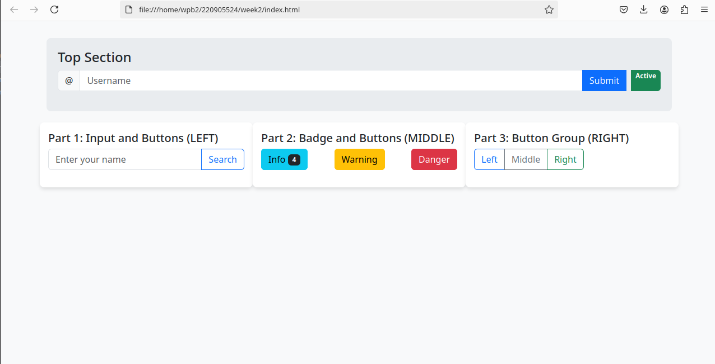
__________________________________X_________________________________

